BALLARAT WILDLIFE PARK
BOOKING FORM
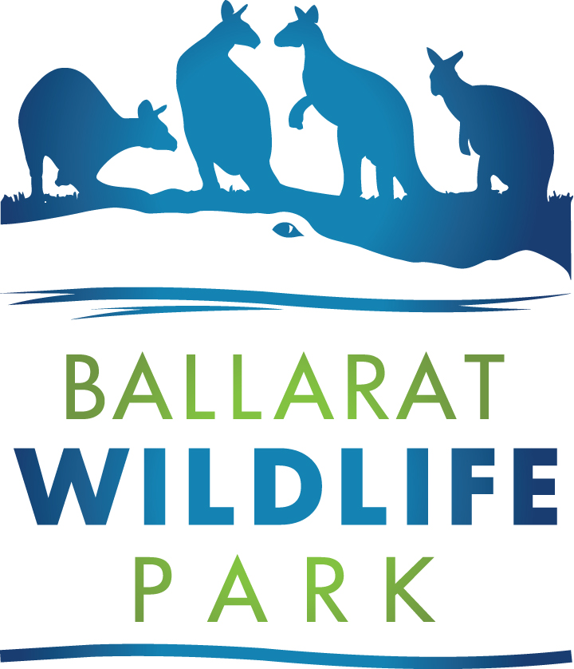

School details:

Name of school/organisation:
Booking contact name:
Booking contact phone number:
School postal address:
School accounts email address: (for invoicing purposes):
Estimated time of arrival: am/pm
Date of visit: / /
School contact phone number:
School contact email address:
Student details:
Number of students: Year level:
Total number of teachers/staff:
(teachers free of charge at a ratio of 1:10 students)
Wildlife Park visit details:
Hire of our Bushman’s Hut: Please circle Yes / No
(additional charge of $100.00):
Payment details:
Admission rates: 1st April 2023-31st Mar 2024
Students aged 5-15 years: $15.00
Concession/students Year 11 & 12: $23.00
Additional adults: $27.00
All prices include GST

Payment method: Please circle: cheque / invoice / cash

If paying by invoice, please ensure you bring an official school purchase order with you on the day

Please email the completed form to: info@wildlifepark.com.au

