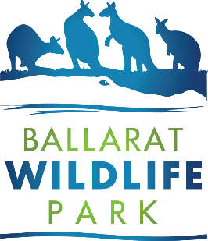
BALLARAT WILDLIFE PARK
SCHOOL GROUP BOOKING FORM

School details:
Name of school:
Contact name: |  |  |  |  |  |  |  | Contact phone:
Postal address (for invoicing purposes):
Estimated time of arrival: am/pm |  |  |  |  |  | Departure time: am/pm |  |  |  |  | Date of visit / /
Contact phone number:
Contact email:
Student details:
Number of students: |  |  |  |  |  |  |  | Year level:
Additional teachers ($24.00 each): |  |  |  |  |  |  |  | Teachers free of charge at a ratio of 1:10 students
Wildlife Park visit details:
Free Guided Tour of the Wildlife Park (minimum of 20 students, please tick one box): |  |  |  |  |  |  |  |  |  |  |  |  | YES |  |  | NO
Preferred time of tour: 10.30am or 12.00pm |  |  |  |  |  |  |  | Duration of tour (if applicable):
Hire of our Bushman’s Hut ($100.00): |  |  |  | YES |  |  | NO |  |  | Requested time:
Areas of learning focus at the Wildlife Park:
Payment details:
 |  | Admission rates:  Students aged 5-15 years:  Concession/students Year 11 & 12:  Additional adults: |  |  |  |  |  |  | Jan 1st 2019 – Dec 31st 2019  $15.20  $ 20.50  $24.00
 |  | All prices include GST
Please note: minimum of 20 paying people to receive group rates
Payment method (please circle): |  |  | CHEQUE |  |  |  |  |  |  | INVOICE |  | CASH
If paying by invoice please ensure you bring an official school purchase order with you on the day
Email the completed form to: info@wildlifepark.com.au

